Hypothesis 1 - Ethanol encounters vs trajectory tortuosity
Odor-guided orientation trajectory analysis | pooled Loc1-6 | unit = trial

1. Goal and hypotheses
Goal: test whether the number of ethanol encounters a mouse experiences during a trial relates to how tortuous (winding) its search trajectory is.
H1 (prediction): Across pooled Loc1-6 trials, ethanol encounters are NEGATIVELY associated with trajectory tortuosity - more encounters imply a straighter (less tortuous) path.
H0: No monotonic association (Spearman rho = 0).
Acceptance rule: Accept H1 only if rho < 0 with a 95% CI excluding 0; otherwise report the honest direction and significance.

2. Methods
Data source: C:\Projects\Repos\Mouse Arena\DATA\Mouse Arena Aggregate Data.h5. Trajectory metrics were computed by the shared accessor + traj_common (traj_common/1.0) and saved to data/trajectory_metrics.json and data/trajectory_metrics.h5; group-level statistics were saved to data/stats.json. All figures and numbers in this report are read from those saved result objects (no re-computation of the science).
Interpreter: the project virtual environment python (vras/Scripts/python.exe), matplotlib headless (Agg backend). Random seed = 1234 (used for all trial bootstraps, n_boot = 2000).
Encounter detector: ethdeconv signal on the head clock, k = 5 (MAD-based), threshold = 0.000718161 a.u.; quiet-period false-positive rate = 9.477e-05 per second (target max 0.05, within target = True).
Tortuosity (definition D6): path_length / straight_line on the cleaned body-centroid track, where path_length = sum of ||delta p|| over kept consecutive samples and straight_line = ||p_end - p_start|| (guard straight_line >= 1 px). Unitless.
Unit of analysis: the trial. Pooled set = Loc1-6, n = 105 trials. anotherLoc (n = 9, heterogeneous with extreme path lengths/tortuosity) is reported separately and excluded from the pooled statistics and the pooled fit. Total trials processed = 114, skipped = 0.
Statistic: Spearman rho with 95% CI by trial-level bootstrap (the tortuosity distribution is heavy-tailed). Direction is reported before significance throughout.

3. Results
Headline: H1 as stated is NOT supported. The primary raw association is strongly POSITIVE (Spearman rho = 0.612, 95% CI [0.454, 0.736], p = 3.93e-12, n = 105) - i.e. more encounters go with MORE tortuous paths, the OPPOSITE of the predicted negative relationship. This raw positive is, however, largely a PATH-LENGTH EXPOSURE ARTIFACT; the exposure-normalized encounter measure is null (see 3.2). accept_H1 = False.

3.1 Primary (raw) association and reconciliation with the prior
Raw Spearman rho(n_encounters, tortuosity) = 0.612 [0.454, 0.736], p = 3.93e-12 (n = 105), direction = positive. The prior Plume-locations Task-1 run reported rho = +0.176 (p = 0.072) on the same trials - weak, non-significant, but already POSITIVE (opposite the H1 prediction). The present result reproduces that positive sign and is far stronger.
Prior (Plume-locations Task-1): rho=+0.176, CI[-0.016,0.356], p=0.072 (weak, non-significant, POSITIVE = opposite the H1 prediction). H1 accepted only if rho<0 and CI excludes 0.

3.2 Exposure confound and the exposure-normalized (null) result
encounter_rate = n_encounters / path_length is the exposure-normalized encounter measure; raw n_encounters scales with path length/time, so rho_encounter_rate_vs_tort controls for that exposure confound.
Both variables scale with path length (exposure): rho(n_encounters, path_length) = 0.710 [0.595, 0.797], p = 2.14e-17; and rho(tortuosity, path_length) = 0.925 [0.842, 0.980], p = 4.28e-45. Longer trials accumulate both more encounters and more tortuosity, manufacturing a spurious positive correlation between them.
Normalized for exposure, the relationship collapses to null: rho(encounter_rate = n_encounters/path_length, tortuosity) = 0.077 [-0.107, 0.260], p = 4.37e-01, n = 105. The 95% CI spans 0 and the direction is not interpretable; there is no evidence of the predicted (or any) monotonic relationship once exposure is controlled.

3.3 Secondary measure: fraction of path spent above threshold
An exposure-insensitive alternative - the fraction of kept samples whose aligned ethdeconv exceeds threshold - reproduces the prior negative association: rho(frac_path_above_threshold, tortuosity) = -0.419 [-0.562, -0.253], p = 8.70e-06 (n = 105), direction = negative (prior rho = -0.532). Straighter (shorter) paths spend a larger fraction of their path in odor. This is the one measure consistent with the spirit of the H1 prediction, but note it is a fraction, not the raw encounter count that H1 was stated on.

3.4 Per-location Spearman rho (n_encounters vs tortuosity)
Location | Spearman rho | p | n
Loc1 | 0.397 | 0.0832 | 20
Loc2 | 0.742 | 0.0004227 | 18
Loc3 | 0.581 | 0.01451 | 17
Loc4 | 0.682 | 0.007207 | 14
Loc5 | 0.365 | 0.1495 | 17
Loc6 | 0.783 | 7.338e-05 | 19
All six pooled locations show the same positive raw sign, consistent with a shared exposure driver rather than a location-specific effect.

3.5 anotherLoc (reported separately, excluded from pooled stats/figures)
anotherLoc (n = 9): rho(n_encounters, tortuosity) = 0.126 (p = 0.7476); rho(frac_above, tortuosity) = -0.267 (p = 0.4879). These are small-n and not pooled with Loc1-6.

3.6 Encounter diagnostics: the calibrated threshold sits at the noise floor
The calibrated encounter threshold (7.18e-04 a.u. on ethdeconv_on_head_clock) sits at the deconvolved NOISE FLOOR, not at a physically meaningful odor amplitude. The pooled per-trial median ethdeconv (the noise floor) is 4.34e-04 a.u., and the median ethdeconv AT the 7814 detected onsets is 7.45e-04 a.u. - the same order of magnitude as both the threshold and the noise floor - whereas real odor reaches ~0.14 a.u. (signal_max_ref). Only a fraction 2.56e-04 of onsets (i.e. ~0%) exceed the physically meaningful 0.01 a.u. amplitude.
At a physically meaningful amplitude, encounters collapse to ~0-1 per trial. Re-counting encounters with a secondary amplitude threshold of 0.01 a.u. gives per-trial n_encounters_amp median 0 (min 0, max 5, mean 0.35) - i.e. discrete high-amplitude odor contacts are essentially absent, matching the request's original guess of roughly 0-1 real contacts per trial.
Interpretation: the ~28 onsets/trial index low-amplitude noise/exposure crossings, NOT discrete high-amplitude odor contacts. This REINFORCES the H1 conclusion: the raw positive rho(n_encounters, tortuosity) = 0.612 is a path-length exposure artifact, and the exposure-normalized association is null (rho = 0.077, p = 4.37e-01, CI spans 0).
smallest-k rule returns the most permissive threshold on this degenerate (near-silent) quiet baseline; harmless here because all encounter-dependent results are null, but should not be used to support a positive claim.

Figure F1 - Encounters vs tortuosity scatter
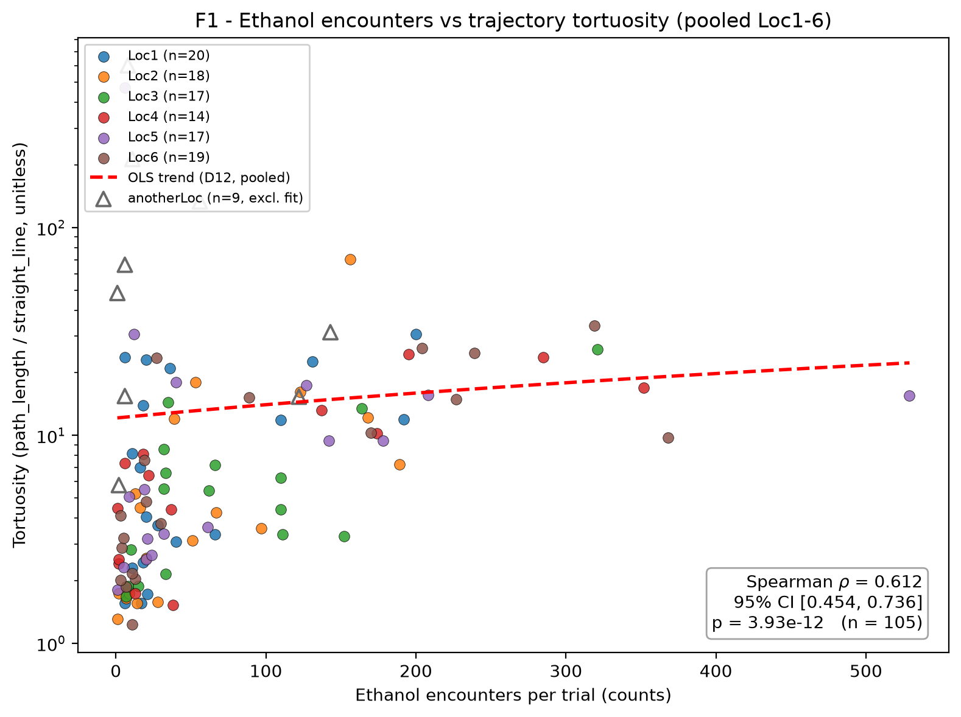
Figure F1. One point per pooled Loc1-6 trial (n = 105); x = ethanol encounters (counts), y = tortuosity (unitless, log scale). Points colored by end location; dashed red line = OLS trend of tortuosity on n_encounters (display only, D12). anotherLoc trials (triangles, n = 9) are excluded from the fit. Annotation: Spearman rho = 0.612, 95% CI [0.454, 0.736], p = 3.93e-12. The positive slope is the raw (exposure-confounded) association; see 3.2 for the null normalized result.

Figure F2 - Most/least tortuous example paths
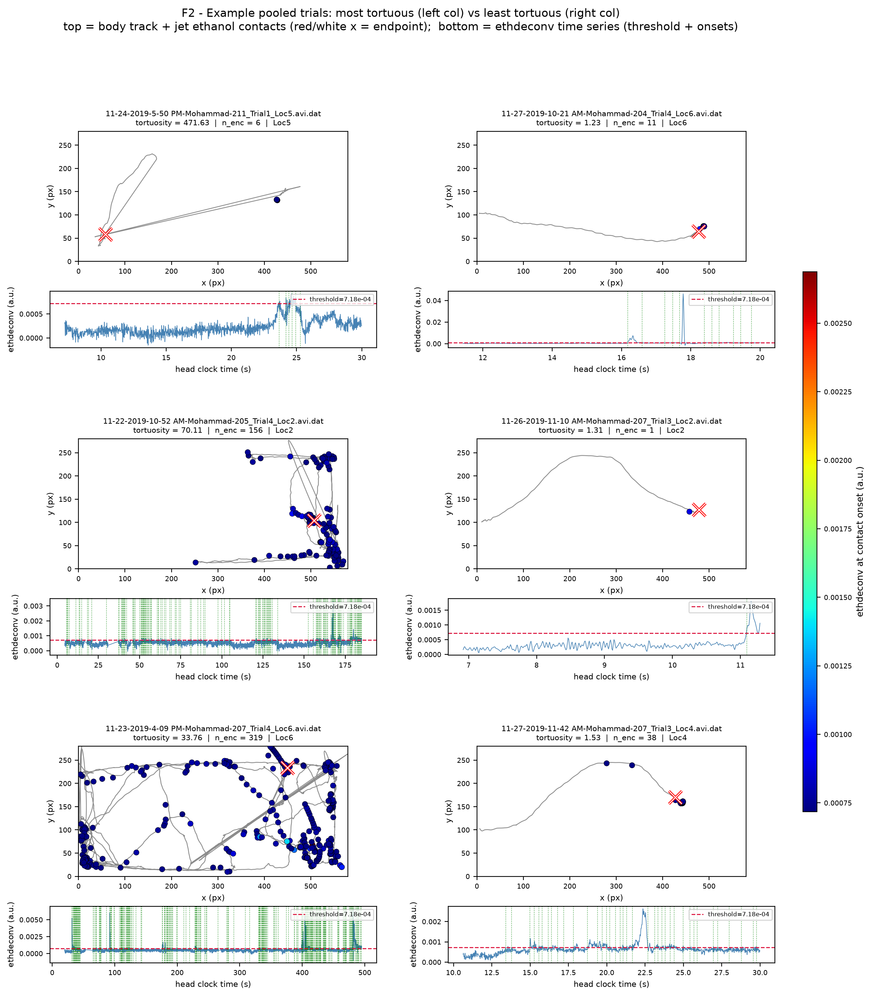
Figure F2. Six example pooled trials: the three most tortuous (left column) and three least tortuous (right column). Each cell: top = cleaned body-centroid track within the arena box ([0,580] x [0,280] px, equal aspect) with the source endpoint marked (red/white x) and ethanol contacts (head positions at detected onsets) scatter-colored by ethdeconv at onset (jet colormap); bottom = that trial's ethdeconv time series on the head clock with the detector threshold (7.18e-04 a.u., dashed red) and vertical onset marks. Each panel is titled with its file_name and tortuosity.

4. Caveats
- Exposure confound (primary caveat): raw n_encounters and tortuosity both scale with path length (rho = 0.710 and 0.925 respectively), so the raw positive association is largely an artifact. The exposure-normalized encounter_rate vs tortuosity is null (rho = 0.077, p = 4.37e-01, CI spans 0).
- Encounter counts are low on this cohort (pooled per-trial median=28); H1 correlation with n_encounters has limited dynamic range.
- Encounter-count magnitude: pooled per-trial n_encounters median = 28 (min 1, max 529), limiting dynamic range.
- Single cohort; infrared/uncalibrated ethdeconv signal in arbitrary units (a.u.); spatial units in pixels (uncalibrated to physical distance).
- Conclusion: H1 (encounters -> straighter) is NOT supported. The strong raw positive is an exposure artifact; the exposure-normalized relationship is null; only the frac-above-threshold measure shows a negative association consistent with the prediction's spirit.

5. Reproducibility
Seed = 1234; traj_common traj_common/1.0; created_utc (result objects) = 2026-08-08T04:40:54Z.
Result files (read-only inputs to this report):
- data/stats.json
- data/trajectory_metrics.json
- data/trajectory_metrics.h5
Exact commands (interpreter = vras/Scripts/python.exe):
AR_PY="C:/Projects/Repos/Agentic Research/Research Setup/vras/Scripts/python.exe"
"$AR_PY" code/make_F1.py
"$AR_PY" code/make_F2.py
"$AR_PY" code/make_H1_report.py

